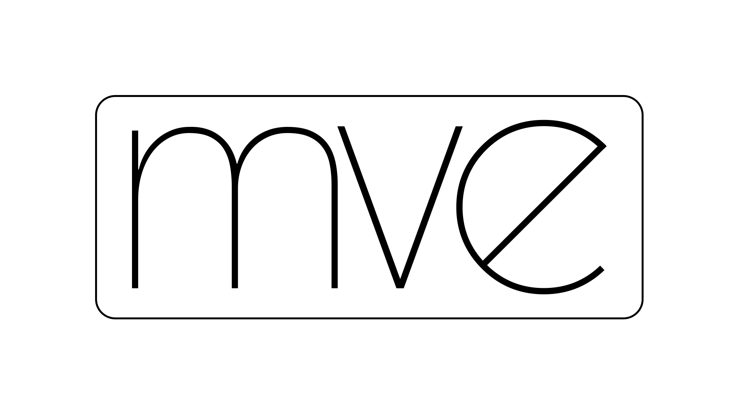

Music & Special Requests Sheet

Name:

Date of Event:

Top 5 Requests:

1.)
2.)
3.)
4.)
5.)

Please list some of your favorite songs and artists along with any special requests that you may have:

Please list any songs or routines that you dislike (YUCK!)

Notes:

